

Ethical Decision Making

Framework & Worksheet  
ORG.1810.PL.005.FORM.01

**Ethical Decision Making Framework**

IDEA

1. Identify.

* **Ethical dilemma**
* **Relevant facts**
* **Patient preferences**
* **Evidence**
* **Contextual features**

***Ask: What is the ethical dilemma?***

2. Determine.

* **Stakeholders (all relationships)**
* **Relevant ethical principles**
* **Additional factors/dilemmas**

***Ask: Have perspectives of relevant individuals been sought?***

4. Act.

* **Implement chosen option**
* **Document and communicate decision to relevant parties**
* **Evaluate decision/plan**

***Ask: Are we (am I) comfortable with this decision?***

3. Explore.

* **Options (at least 3 options)**
* **Strengths and limitations**
* **Mission, vision, values, and policies**
* **Make a choice**

***Ask: What is the most ethically justifiable option?***

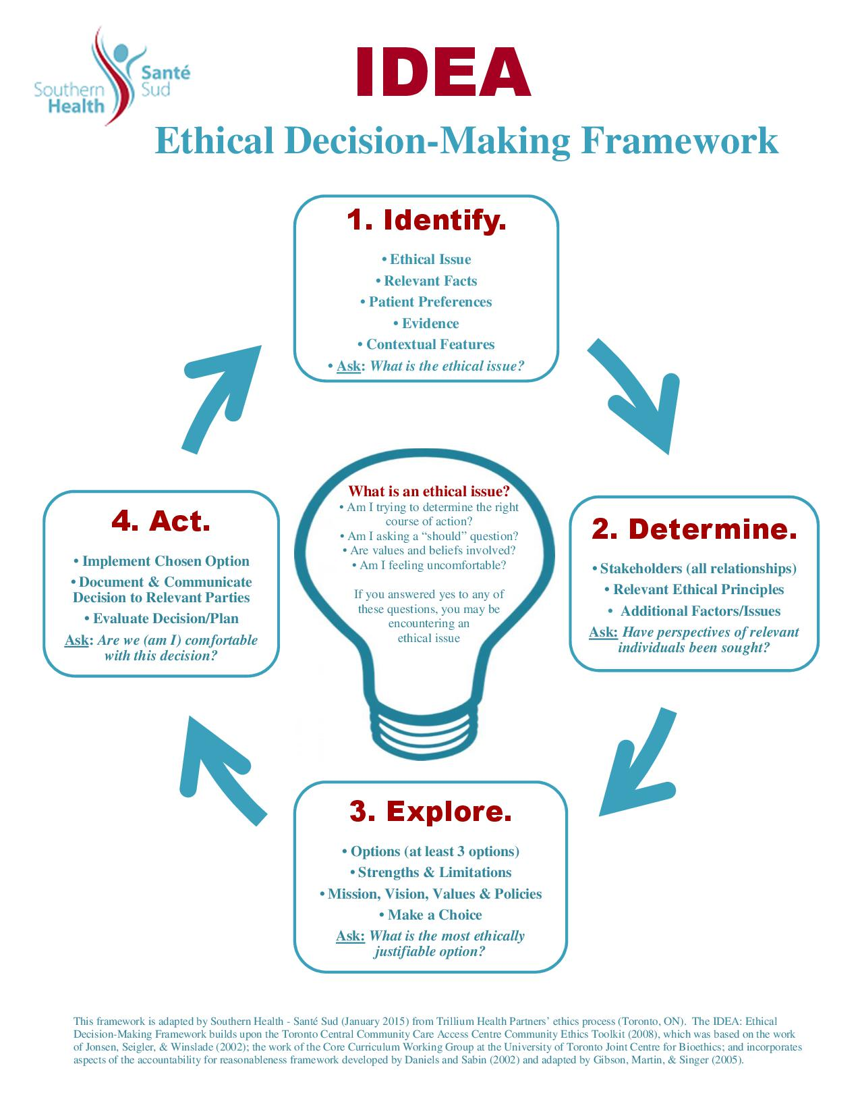



**What is an ethical dilemma?**Am I trying to determine the right course of action?

Am I asking a “should” question?

Are values and beliefs involved?

Am I feeling uncomfortable?

If you answered yes to any of   
these questions, you may  
be encountering  
an ethical  
dilemma

**Appendix B: Ethics Worksheet based on IDEA Framework**

**Date: _______________________**

|  |  |  |  |  |
| --- | --- | --- | --- | --- |
| **Step 1: Identify the Facts** | | | | |
| ***1. What is the presenting ethical dilemma(s)?*** | | | | |
| ***2. What are the relevant medical or other indications?*** *(diagnosis, prognosis, goals of treatment/intervention- benefits & harms, etc.)* | | | | |
| ***3. What are the patient(s) preferences? (if applicable)*** *(re: treatment/intervention, quality of life, ability to make decisions, prior expressed wishes, willingness/ability to cooperate, right to choose)* | | | | |
| ***4. What is the evidence?*** *(standard of practice, data to inform decision, research/literature available, documentation available – advanced directives)* | | | | |
| ***5. What are the contextual features?*** *(family issues, religious or cultural factors, health provider or administrator biases, clinical research, legislation, confidentiality, financial implications, organizational policies [including ”Patient Bill of Rights”], conflict of interest, & mission/vision/values)* | | | | |
| ***6. What is the ethical dilemma?*** | | | | |
|  | | | | |
| **Step 2: Determine the Relevant Ethical Principles.** | | | | |
| ***1. Who are the stakeholders (relevant parties)?*** | | | | |
| ***2. What values/principles are relevant to the dilemma? (see Appendix C and list #’s that are applicable to ethical dilemma)***  *(Rate identified values from 1 to ….)* | | | | |
| ***3. Are there any other factors that need to be considered?*** | | | | |
| ***4. Have perspectives of relevant individuals been sought?*** | | | | |
|  | | | | |
| **Step 3: Explore the Options.** | | | | |
| ***Option 1:*** | ***Option 2:*** | | ***Option 3:*** | |
| **Is Option 1?**  Consistent with laws and policies    Consistent with mission, vision,  values, and strategic directions  Consistent with ethical principles  identified in Step 2, #2. | **Is Option 2?**  Consistent with laws and policies  Consistent with mission, vision, values,  and strategic directions  Consistent with ethical principles  identified in Step 2, #2. | | **Is Option 3?**  Consistent with laws and policies  Consistent with mission, vision, values,  strategic directions  Consistent with ethical principles  identified in Step 2, #2. | |
| ***Benefits/Strengths:*** | ***Benefits/Strengths:*** | | ***Benefits/Strengths:*** | |
| ***Harms/Limitations:*** | ***Harms/Limitations:*** | | ***Harms/Limitations:*** | |
| **What is the most ethically justifiable option?** | | | | |
|  | | | | |
| **Step 4: Act.** | | | | |
| 1. **Documentation/Communication of Decision (who, what, where, how**): | | | | |
| 1. **Implementation Plan:** | | | | |
| 1. **Evaluation Plan:** | | | | |
| 1. **Confirm that the Process has Met the Following Conditions** | | ***Evidence:*** | | ***Reviewed by:*** |
| **Empowerment**: to minimize power differences in the decision-making context and to optimize effective opportunities for participation. | |  | |  |
| **Transparency**: process, decisions and their rationales should be transparent and accessible. | |  | |  |
| **Relevance:** Decisions should be made on the basis of reasons (evidence, principles, arguments) that “fair-minded” people can agree. | |  | |  |
| **Revisions and Appeals**: opportunities to revisit and revise decisions in light of further evidence or arguments. | |  | |  |
| **Compliance:** Voluntary or public regulation of the process to ensure that the other four conditions are met. | |  | |  |
| 1. ***Are we (am I) comfortable with this decision?*** | | | | |
|  | | | | |

**Appendix C: Ethical Values/Principles**

**1. AUTONOMY: Respect for autonomy** (respect people's right to self-determination or self-governance such that their views, decisions and actions are based on their personal values and beliefs; the vehicle for this principle in health care and research is generally the free and informed consent process).

**2. BENEFICENCE: Act beneficently toward others** (contribute to the welfare of others, which may include preventing harm, removing harm, promoting well-being, or maximizing good).

**3. COMMON GOOD:** A specific "good" that is shared and beneficial for all (or most) members of a given community.

**4. CONFIDENTIALITY: Keep private information confidential** (keep identifying personal information as well as confidences secret, unless consent to disclose this information is given by the person to whom it belongs or disclosure is required by law).

**5. CONFLICT OF INTEREST: Disclose conflicts of interest and avoid disqualifying conflicts of interest** (disclose both real and perceived conflicts between one’s self-interest and/or one’s obligations to one or more individuals or groups).

**6. DIGNITY: Respect the dignity of morally valuable beings** (treat beings in a way that honors their value or worth based on morally significant qualities, e.g., sentience, relationality, rationality).

**7. DISCLOSURE: Disclose information that people or groups have a right to** (provide information needed to make an informed decision, and information about errors or adverse events in treatment or research).

**8. DIVERSITY: Respect diversity** (accommodate, protect or support differences, including religious, cultural, political and other differences, among people and groups).

**9. INCLUSIVENESS: Involvement/representation of everyone who is part of a problem situation** based on notion that each brings knowledge or expertise needed to address the problem and feel ownership of the solution.

**10. INTEGRITY: Act with integrity** (give priority to ethical considerations even when there is a strong drive for self-interest or other desires, or where violating ethical requirements could pass unnoticed).

**11. JUSTICE: Promote justice and fairness** (treat people and groups fairly by treating morally relevant cases alike, by promoting fair relations among individuals and social groups, and by ensuring fair and equitable access to resources and opportunities, including fair distribution of benefits and burdens).

**12. NON-MALEFICENCE: Act so as to do no harm** (avoid causing harm to individuals or groups, or risking harms of significant magnitude and probability).

**13. PATIENT-CENTRED or FAMILY-CENTRED CARE: Provide patient-centred or family-centred care** (organize and provide therapies, services, interventions and interactions in ways that respect and respond to the patient’s or family’s values, preferences, decisions or self-identified best interests).

**14. RIGHTS: Protect the rights of individuals and groups** (honor the legitimate moral and legal claims of individuals/groups).

**15. SAFETY: Ensure safety** (avoid injury and reduce risks of harm to patients, research participants, families, staff and other members of the community; promote a culture that reports errors and near-misses and strives to improve the safety of clinical, research and organizational environments).

**16. SOLIDARITY: Requires consideration of the extended community** and acting in such a way that reflects concern for the well-being of others.

**17. STEWARDSHIP:** The **careful and responsible management** of something entrusted to one's care (e.g., public healthcare dollars).

**18. TRANSPARENCY: Make decision-making transparent** (communicate and make accessible decisions and their rationales to all stakeholders).

**19. UTILITY:** Maximizing the **greatest possible good for the greatest possible number** of individuals

**Appendix D**

**Southern Health-Santé Sud Vision, Mission, Core Values, and Strategic Priorities**

**Vision**

Healthier people, Healthier communities, Thriving together.

**Mission**

Partnering with our communities, we provide safe, accessible

and sustainable people-centred health care

**Core Values**

*Uncompromising INTEGRITY*  
We build trust through accountability, authenticity and responsiveness in everything we do.

*Healing COMPASSION*We empower hope for the whole person, being there along the journey with kindness, generosity and empathy for another’s reality.

*Pursuit of EXCELLENCE*We put forth our personal and professional best in our commitment to the highest standards of safety, quality and service.

*RESPECT for all*We commit to inclusion and equity, and embrace diversity of culture, transitions, identify, ability and thought.

Purposeful INNOVATION

We courageously create new opportunities and collaboratively generate solutions for a sustainable future.

**Strategic Priorities**

A focus on quality health services

*A Positive Experience*

Improved health system performance

*A Healthy, Empowered and Thriving Workforce*

*Intentional Community Engagement*

*Sustainable Health Services*