**2021 WHMIS Quiz**

**Carefully read each question and match or circle the letter of the correct answer.**

1. Match the correct answer with the route of entry:

|  |  |
| --- | --- |
| Inhalation: _ | 1. As a grounds keeper I should not be spraying chemicals without wearing protective equipment. i.e. gloves |
| Ingestion: _ | 1. I was working with chemicals in my lab, decided to grab a snack, and forgot to wash my hands. |
| Eye  Contact: _ | 1. I just gave a patient some pain medication and accidentally poked myself with the needle. |
| Skin  Contact: _ | 1. I should have been wearing goggles during the plumbing repair. |
| Skin  Absorption: _ | 1. Next time I will not hesitate to put on personal protective equipment before working with acid and getting it on my hand. |
| Injection: _ | 1. I should have turned on the ventilation fan before starting to weld. |

1. The information provided on the SDS answers some of the basic questions about hazardous materials. Which of the following questions does it answer?
2. What are the hazards of the hazardous material?
3. What precautions should I take?
4. What do I do in an emergency?
5. All of the above.
6. SDS’s should be easily accessible at all times to all workers who work with or near hazardous material.
   1. True
   2. False
7. Hazardous Product Precautionary Statements provide advice about storage, use, first aid, personal protective equipment, and emergency measures. You can find these statements on the:
8. Safety Data Sheet (SDS)
9. Label
10. Both the label and SDS
11. Neither the label nor the SDS
12. [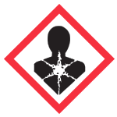](https://www.google.ca/url?sa=i&rct=j&q=&esrc=s&source=images&cd=&cad=rja&uact=8&ved=0ahUKEwiB_qnfiLLXAhVl04MKHaQHDgcQjRwIBw&url=https://www.ccohs.ca/oshanswers/chemicals/whmis_ghs/pictograms.html&psig=AOvVaw0BtcyqKfRxpxOHtUFnLZRS&ust=1510336677912772)The Health Hazard Pictogram is

What health hazards does this pictogram represent?

1. Products labeled with this pictogram may cause health effects like cancer over a long period of time.
2. The product may be aspirated, meaning that it can be breathed into the lungs, which is harmful or sometimes fatal.
3. The products may cause allergy or asthma symptoms.
4. All of the above may be represented by the Health Hazard Pictogram.
5. Which pictogram would you expect to find on an oxygen tank?

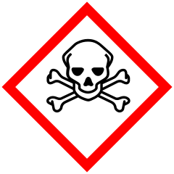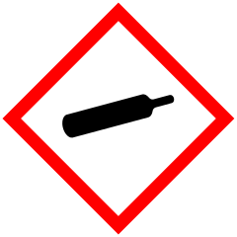[](https://www.google.ca/url?sa=i&rct=j&q=&esrc=s&source=images&cd=&cad=rja&uact=8&ved=0ahUKEwiB_qnfiLLXAhVl04MKHaQHDgcQjRwIBw&url=https://www.ccohs.ca/oshanswers/chemicals/whmis_ghs/pictograms.html&psig=AOvVaw0BtcyqKfRxpxOHtUFnLZRS&ust=1510336677912772)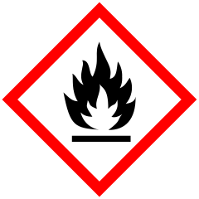a. b. c. d.

1. Consumer products have their own unique label but they can be as hazardous as workplace products.
   1. True
   2. False
2. It would be okay to use an unlabeled spray bottle with liquid in it to clean or disinfect surfaces.
   1. True
   2. False

**Answer Key – 2021 WHMIS Quiz**

1. Inhalation – f; ingestion -b; eye contact – d; skin contact – e; skin absorption – a; injection - c

2. D

3. A

4. C

5. D

6. C

7. A

8. B